
Wireshark test capture
Cybersecurity & Ethical Hacking

APSPL2628505

Apex Planet

1. Objective
The objective of this experiment is to capture and analyze network packets using Wireshark. This helps in understanding how data travels across the network and how different protocols such as TCP, HTTP, and DNS operate during communication.

2. Tools and Environment
The following tools and environment were used:
- Kali Linux – Operating system used for network analysis
- Wireshark – Tool used to capture and analyze network packets
- Web Browser – Used to generate network traffic
- Virtual Machine / Local System – Environment where Wireshark was executed
- Network Interface (Ethernet/Wi-Fi) – Used to capture packets

3. Steps
Step 1: Start Wireshark
Open Wireshark from the application menu.
Command (optional if opening from terminal : wireshark

Step 2: Select Network Interface
- Choose the active network interface (Wi-Fi or Ethernet).
- Click Start Capturing Packets.

Step 3: Generate Network Traffic
To generate packets for analysis:
- Open a web browser.
- Visit a website such as:
https://www.google.com
This generates HTTP/HTTPS and DNS traffic.

Step 4: Stop Packet Capture
After capturing packets for a few seconds:
- Click the Stop Capture button in Wireshark.

Step 5: Apply Filters
Use Wireshark filters to analyze specific protocols.
Example filters:
DNS traffic:
dns
HTTP traffic:
http
TCP packets:
tcp

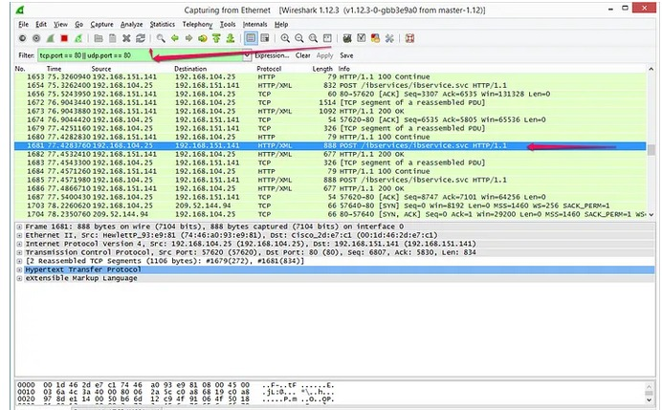
Wireshark Test Capture

4. Analysis / Interpretation
The captured packets show communication between the client system and remote servers. DNS packets resolve domain names into IP addresses before the connection is established. TCP packets demonstrate the three-way handshake used to establish reliable communication between devices. HTTPS packets show encrypted communication between the browser and the web server.
By analyzing these packets, it is possible to understand network behavior and detect unusual or suspicious traffic patterns.

5. Mitigation / Recommendations
To ensure secure network communication:
- Use encrypted protocols such as HTTPS instead of HTTP.
- Monitor network traffic regularly to detect suspicious activity.
- Implement firewalls and intrusion detection systems.
- Restrict access to sensitive network interfaces.
- Regularly analyze network logs to identify potential threats.

6. Conclusion
This experiment demonstrated how to capture and analyze network packets using Wireshark. The captured traffic provided insights into network communication and protocol behavior. Understanding packet-level communication is essential for network troubleshooting and cybersecurity analysis.

